**ON THE CALCULATION OF CONVECTIVE HEAT RECOVERY UNDER MUTUAL-ACTION OF A JET WITH A LIMITING SURFACE**

**I.A. Pribytkov and S.I. Kondrashenko**

National University of Science and Technology “MISIS” (MISIS),

Moscow, Russia

***Abstract:*** A method for calculating convective heat transfer in the interaction of a single circular jet with a flat surface is proposed. The concepts “energodynamic potential of the flow” and “energodynamic power of the flow” are introduced, allowing to determine the intensity of convective heat transfer at the “gas-solid” boundary. The differences of the proposed definitions from the existing ones are given: heat flux density and heat flux.

When calculating the heat transfer, it was proposed to divide the jet when interacting with the flat surface into two parts: before the interaction - the jet part, after - the fan flow.

The method for calculating convective heat transfer under jet heating, in which the Reynolds criterion calculated by the characteristics of the gas at the nozzle exit is decisive, is not entirely correct; It is proposed to use criteria specific to the fan flow. Characteristic values ​​for the fan flow are the initial average velocity of the fan flow Uvp, the distance from the critical point of the jet (the point of intersection of the vertical axis of the jet with the surface) to the current coordinate of the radius.

*Keywords: jet heating, “attacking” jet, fan flow, convective heating, numerical simulation, convective heat transfer, fields of velocity, Reynolds criterion. energy-dynamic potential, energy-dynamic power.*

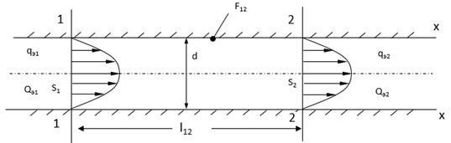

Fig. 1 - The movement of a liquid or gas inside a pipe of circular cross section

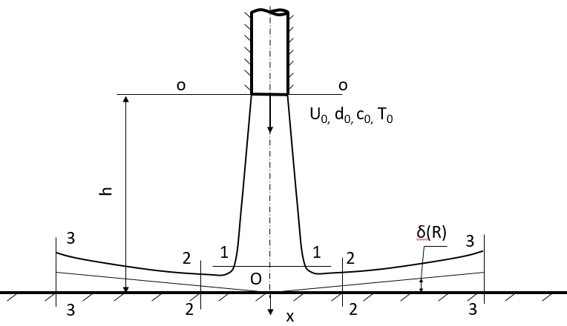

Fig. 2 – Calculated flow pattern when the jet hits a flat surface

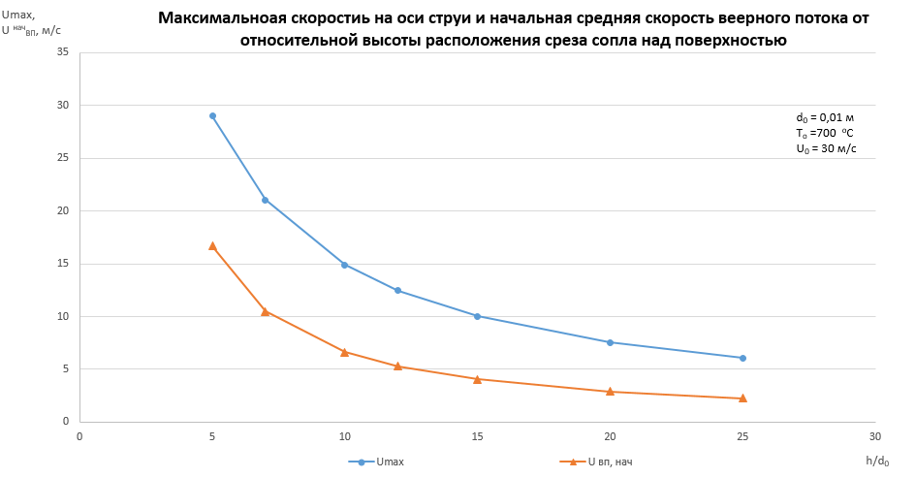

Fig. 3 - The change in the maximum velocity on the jet axis $U_{max}$ on the main plot and the initial average over the cross section of the velocity of the fan flow $U_{вп}^{нач}$ depending on the distance h/do

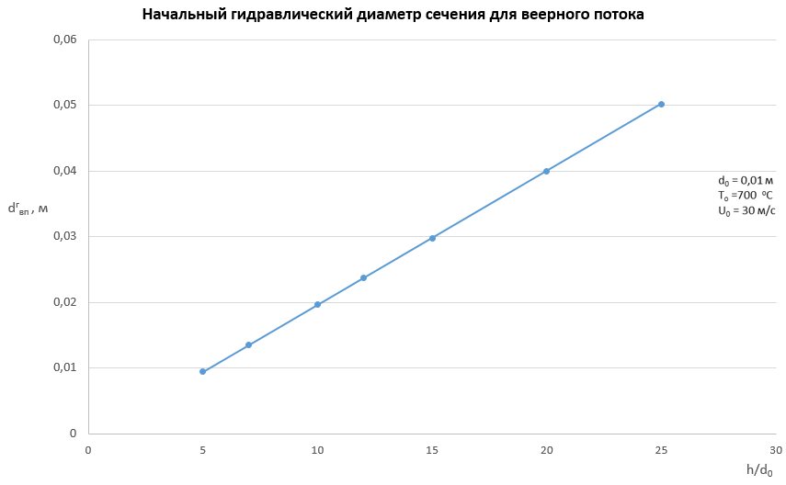

Fig. 4 - Change of initial hydraulic diameter of fan section flow height of the jet part of the flow

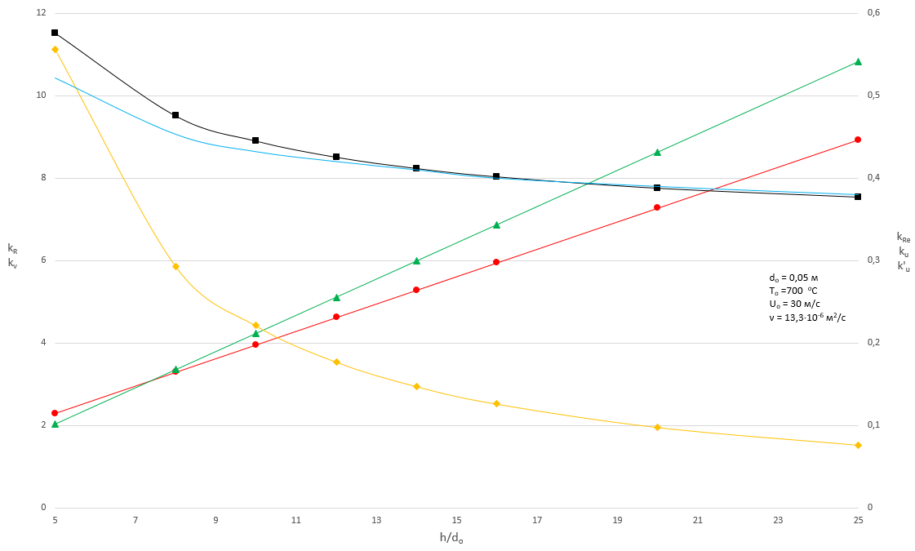

kv

kR

kRe

k’u

ku

Fig. 5 - Dependence of the ratio of expansion coefficients of the jet $k_{R}$, jet injection $k_{V}$, speeds for any section $k_{U}$, speeds for any section except h/do = 0 ${k'}_{U}$, Reynolds criteria $k_{Re}$ from h/do.

**REFERENCES**

1. Astsaturov V.N. Krasnokutsky P.G., Investigation of heat transfer during jet heating of blanks. Izvestiya VUZov. Chernaya metallurgiya = Izvestiya. Ferrous Metallurgy. Moscow. 1978, (1), 5–12 p. (In Russ.)
2. Astsaturov V.N., Berkovskay P.S., Krasnokutsky P.G., Investigation of metal heating by attacking jets in the development of multi-row furnaces, Tr. VNIIPITeploprect: ovens and dryers in the engineering industry. 1978, (45), 3-10 p. (In Russ.)
3. Vokhmyakov A.M., Kazyaev M.D., Kazyayev D.M. Investigation of convective heat transfer in a through furnace equipped with high-speed burners. Tzetnie metally = “Non-ferrous metals”. Moscow: 2011, (12), 89-93 p. (In Russ.)
4. Pribytkov I.A., Energy-saving methods of metal heating based on the use of jets // Automated furnaces and energy-saving technologies in metallurgy. Мoscow.: Izd. Dom MISiS, 2002, 375 – 390 p.
5. Pribytkov I.A., Calculation of the thermal state of the metal during pulse-rate heating. // Izvestiya VUZov. Chernaya metallurgiya = Izvestiya. Ferrous Metallurgy. Moscow. 1995 (71), 53 p.
6. Pribytkov I.A., On the distribution of heat load during pulse-rate heating of metal. Izvestiya VUZov. Chernaya metallurgiya = Izvestiya. Ferrous Metallurgy. Moscow. 1997 (7), 66 p. (In Russ.)
7. Timoshpolski V.I., Trusova I.A., Ratnikov P.E. Possibilities of Application of Jet Heating of Metal Before Rolling. Litiyo I Metallurgiya (Foundry Production and Metallurgy). 2007;(2):63-66. (In Russ.)
8. Yudaev B.N., Mikhailov M.S., Savin V.K. Heat transfer in the interaction of jets with obstacles. - Moscow: Engineering, 1977. - 247 с.
9. Lisienko, V.G., Shleimovich, E.M. Improving the thermal characteristics of furnaces and the operating conditions of the lining by improving direct-flame-impingement methods for intensifying the heating of metal. // Refractories and Industrial Ceramics, 2013; 54 (3), p. 188-195
10. Biryukov AB, Gnitiev PA, Intensification of convective heat exchange in heating and thermal furnaces. Izvestiya VUZov. Chernaya metallurgiya = Izvestiya. Ferrous Metallurgy. Moscow. 2017, (3), 105-112 c.
11. Pribytkov I.A., Titova G.V. Features of jet heating of thermally thin metal. - Izvestiya VUZov. Chernaya metallurgiya = Izvestiya. Ferrous Metallurgy. Moscow. 1993, (9-10), 51 р. (In Russ.)
12. Pribytkov I.A., Calculation of the thermal state of a metal in pulse-speed heating. - Izvestiya VUZov. Chernaya metallurgiya = Izvestiya. Ferrous Metallurgy. Moscow. 1995, (1) 53 р. (In Russ.)
13. Kurnosov V.V., Shultz L.A., Problems of non-oxidizing non-carburizing high-temperature heating of steel in fuel furnaces and possible solutions. Izvestiya VUZov. Chernaya metallurgiya = Izvestiya. Ferrous Metallurgy. Moscow. 2012, (11), 10-14 p. (In Russ.)
14. Gusovsky VL, Lifshits A.E. Method of calculating heating and thermal ovens: Educational reference book. – Мoscow.: Heat engineer, 2004. – 400 с.
15. Abramovich G.N. Theory of turbulent jets / Reprinted edition 1960.

Moscow. ECOLIT, 2011. – 720 p. (In Russ.)

1. Abramovich G.N. Applied gas dynamics. In 2 h. Part 1: Teaching guide. – Мoscow; Science, 1991. – 600 с.
2. Michalke A., On spatially growing disturbances in an inviscid shear layer. J. Fluid Mech. (1965). vol. 23, part 3, pp. 521-544. Printed in Great Britain.
3. Liepmann, D., and M. Gharib. 1992. The role of streamwise vorticity in the nearfield entrainment of round jets. J. Fluid Mechanics 245:643-68.
4. Astsaturov V.N. Intensification of the thermal work of heating furnaces // Proceedings of the 2nd Intern. scientific-practical. Conf. "Automated furnace units and energy-saving technologies in metallurgy". Moscow: Izd. Dom MISiS, 2002, 36-40 p. (In Russ.)
5. Krivandin V.A., Arutyunov V.A., Belousov V.V. and others. Heat engineering of metallurgical production. T.1. Theoretical basis – Мoscow.: Izd. Dom MISiS, 2001. – 608 с.